INVITATION TO BID

CASH RENT LEASE

The City of Kewanee will accept bids for cash rent for farm ground located at various City- owned locations for a three-year period beginning on March 1, 2021 and ending on February 28, 2024. There are 81.9 tillable acres of farm ground in four fields. Bids must be submitted on a Bid Form provided by the City of Kewanee and must be received at Kewanee City Hall, 401 E. Third Street, Kewanee, Illinois, on, or before November 10th at 10:00 a.m. Bids will be opened and read aloud at that time. The Kewanee City Council is anticipated to act on the Bids at a subsequent City Council meeting. Bid packets may be obtained at Kewanee City Hall, 401 E. Third Street, Kewanee, Illinois or online at Cityofkewanee.com. The City of Kewanee reserves the right to accept or reject any or all bids.

SPECIFICATION

SHEET

The following are specifications for placing a bid to rent farmland from the City of Kewanee for the three-year period beginning March 1, 2021 and ending February 28, 2024.

- Bids must be submitted on the Bid Form that is attached hereto. Bids must be per acre based on the 81.9 tillable acres specified in this Invitation to Bid.

- The primary purpose of a portion of the City of Kewanee’s farmland has been land application of biosolids from the Kewanee Waste Water Treatment Plant. The City does not anticipate future application of biosolids on the farmland.

- The information on the farmland included in said lease is as indicated in the table below and on the attached three pages of marked-up aerial photos showing the four fields.

Site | Parcel # | Description | Tillable Acres
Field #1 | 20-34-276-002 (part) | 198 Fischer Ave., field east of Sewer Plant and Transfer Station | 13.2 acres
Field #2 | 20-28-275-003 | 600 Stoner Drive, field west of Stoner and Mary Drives | 11.9 acres
Field #3 | 20-34-376-022 (part) | 1300 E. Division St., south of South Pleasantview Cemetery | 33.6 acres
Field #4 | 25-03-251-026 and  25-03-251-020 | 700 E. Mill St., east and south of Mill Creek Station Subdivision | 23.2 acres
TOTAL |  |  | 81.9 acres

- The acrage of cropland is conservatively estimated by City staff based on data from the Henry County GIS Department. Any disagreement as to the number of acres shall be resolved by both parties accepting the survey results of an Illinois licensed land surveyor commissioned by either party, or jointly, with neither party required to participate in the costs of the survey if commissioned unilaterally by the other party. Absent a survey, the quantity of acres shown in item #3 above shall be used.

- The successful bidder shall enter into a Lease substantially as attached hereto. The proposed lease form should be read carefully and the successful bidder must agree to comply with all terms and conditions in said Lease.

- All bids must be on the bid form provided herewith and must be signed by the bidder. Bids should be placed in a sealed envelope and the bidder should mail or deliver said sealed bid to the City Clerk, Kewanee City Hall, 401 E. Third Street, Kewanee, Illinois 61443-2365. The bidder should sign the outside of the envelope across the seal. Bids must be received on, or before, November 10th, 2020 at 10:00 a.m. Bids will be opened and read aloud at that time. Action on said Bids by the Kewanee City Council will occur at a subsequent City Council meeting.

- Attached to the Bid Form shall also be a letter of credit for the amount of said bid from a financial institution and two (2) letters of recommendation on the bidder’s farming ability.

- The City of Kewanee reserves the right to accept or reject any or all bids.

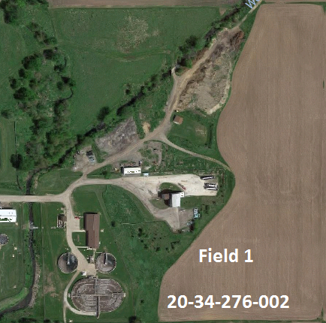

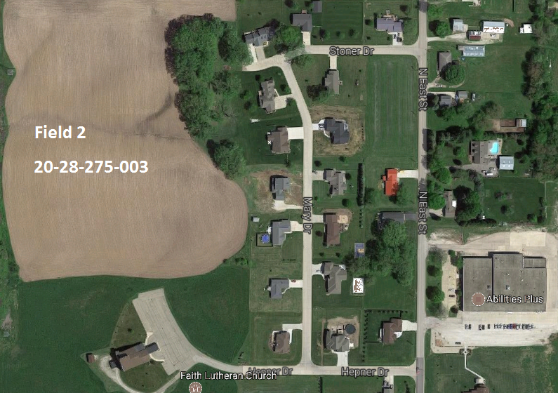

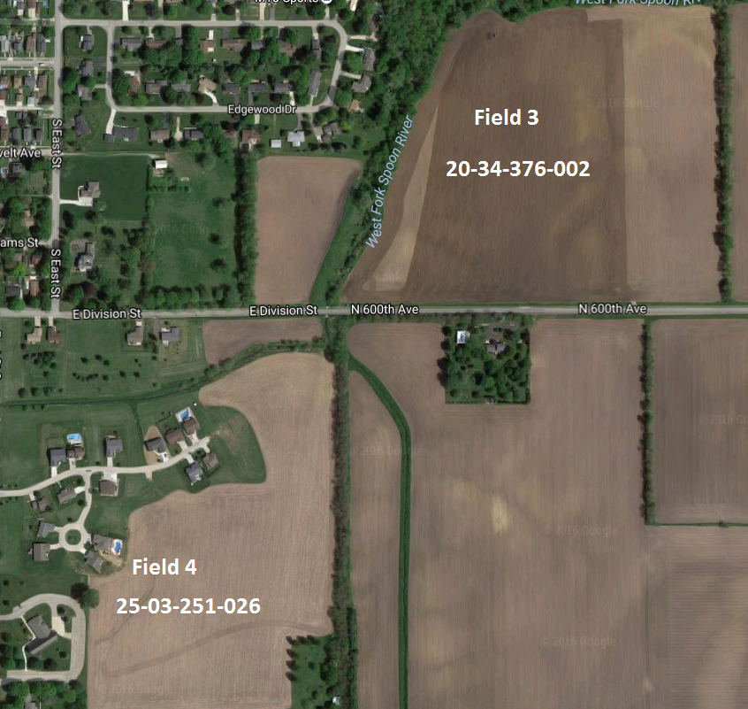

BID FORM

I, the undersigned, submit the following bid to cash rent the tillable acres of farmland at the four fields specified in the Bid document package, under the following terms and conditions.

- I bid the amount of $ by this lease.
per acre for the 81.9 acres of farmland covered

- Attached hereto I have included a letter of credit from my bank or other financial institution and two (2) letters of reference as to my farming ability.

- I agree that, if I am the successful bidder, I will execute a Lease in substantially the form provided me in the Bid Specification Packet, and I will meet and comply with all terms and conditions contained therein including the provision for payment of rent.

Signature

Printed Name

Address

Phone Number

CASH FARM LEASE

This Lease is entered into this day of , 202_by and between the CITY OF KEWANEE, an Illinois municipal corporation, hereinafter referred to as “Landlord”,

AND

Hereinafter referred to as “Tenant”.

WITNESSETH, that the Landlord, for and in consideration of the covenants and agreements hereinafter mentioned, to be kept and performed by the tenant, has by these presents, demised and leased to the Tenant, the farm land of said City of Kewanee, consisting of 81.9 tillable acres according to documentation and aerial photos provided in the Bid Documents. Tenant shall farm only that part of the premises marked as Field #1, Field #2, Field #3, and Field #4 in the Bid Documents. No buildings are included in the leased area.

LENGTH OF TENURE

The term of this Lease shall be from March 1, 2017, to February 28, 2020, and the Tenant shall surrender possession at the end of this term. This Lease shall expire on February 28, 2020, and shall not be automatically extended and no notice shall be required from either party as to the termination of this Lease.

AMOUNT OF RENT

The Tenant agrees to pay the Landlord an annual cash rent for the above-described farm in the
amount of $ per acre. This rent is based upon 81.9 acres of cropland and the total
rent due is $ . The annual cash rent shall be due on or before March 1, 2021, for the 2021 crop year, and March lst of each year during the remaining term of this Lease for those crop years.
Rent payments shall be made payable and delivered to the City of Kewanee, care of Kewanee City Clerk, 401 E. Third Street, Kewanee, Illinois, 61443-2365.

LANDLORD'S INVESTMENT AND EXPENSES

The Landlord agrees to furnish the property and to pay the items of expense listed below:
- Taxes on the land.

TENANT’S INVESTMENT AND EXPENSES

- All seed, inoculation, disease treatment materials, and fertilizers.

TENANT’S DUTIES IN OPERATING FARM

The Tenant further agrees that he will perform and carry out the stipulations below:

  - To cultivate the farm faithfully and in a timely, thorough, and businesslike manner.

  - To inoculate all alfalfa and soybean seed sown on land not known to be thoroughly inoculated for the crop planted.

  - To prevent noxious weeds from going to seed on said premises and to destroy the same and keep the weeds and grass cut.

  - To keep open ditches, tile drains, tile outlets, grass waterways, and terraces in good repair. In the event of a major tile break, Tenant shall notify the City of said break before any repairs are undertaken.

  - To preserve established watercourses or ditches, and to refrain from an operation that will injure them.

  - To keep the fences (including hedges), and other improvements on said premises in as good repair and condition as they are when he takes possession, or in as good repair and condition as they may be put by the Landlord during the term of the Lease - ordinary wear, loss by fire, or unavoidable destruction excepted.

  - To take proper care of all trees, vines, and shrubs, and to prevent injury to the same.

  - To prevent all unnecessary waste, or loss, or damage to the property of the Landlord.

  - To comply with rules and regulations of the Illinois Pollution Control Board, Illinois and United States Environmental Protection Agencies, United States Department of Agriculture, and the Natural Resources Conservation Service. The tenant shall not be responsible for actions of the landlord that may be contrary to said rules and regulations.

  - To plant crops in accordance with the generally accepted farming and soil conservation practices.

  - To provide appropriate yearly fertilizer maintenance on said land at Tenant's expense and to provide proof of said maintenance by submitting copies of the bills for same to the City.

- Activities restricted:

  - The Tenant further agrees, unless he shall first have obtained the written consent of the Landlord:

    - Not to assign this Lease to any person or persons or sublet any part of the premises.

    - Not to erect or permit to be erected any structure or building or to incur any expense to the Landlord for such purpose.

    - Not to permit, encourage, or invite other persons to use any part or all of this property for any purpose or activity not directly related to its use for agricultural production.

    - Not to cut live trees for sale purposes or personal uses.

    - Not to permit the erection of any commercial advertising signs.

    - Not to permit or allow livestock on the property.

DEFAULT, YIELDING POSSESSION, RIGHT OF ENTRY

      - Termination Upon Default. If either party fails to carry out substantially their terms of this Lease in due and proper time, the Lease may be terminated by the other party by serving a written notice citing the instance(s) for default by specifying a termination date of 30 days from the date of such notice.

      - Yielding Possession. The Tenant agrees that at the expiration or termination of this Lease, he will yield possession of the premises to the Landlord without further demand or notice. If the Tenant fails to yield possession, he shall pay to the Landlord a penalty of One Hundred and No/100 ($100.00) Dollars per day or if a penalty is not specified, the statutory double rent shall apply for each day he remains in possession thereafter in addition to any actual damages caused by the Tenant to the Landlord's land or improvements, and said payments shall not entitle said Tenant to any interest of any kind or character in or on the premises.

      - Landlord's Lien for Rent and Performance. The Landlord's lien provided by law on crops grown or growing shall be the security for the rent herein specified and for the faithful performance of the terms of the Lease. If the Tenant shall fail to pay the rent due or shall fail to keep any of the agreements of this Lease, all costs and attorney fees of the Landlord in enforcing collection or performance shall be added to and become a part of the obligations payable by the Tenant hereunder.

      - Landlord's Right Of Entry During Term of Lease. The Landlord reserves the right of himself, his agents, employees, or assigns to enter upon said premises at any reasonable time for the purpose of viewing the same, of working or making repairs or improvements thereon, of developing mineral resources as provided in Clause E below, or after constructive notice has been given that the Lease may not be extended, or plowing after severance or crops, of seeding, or of applying fertilizer and lime and doing other field work, Landlord also reserves the right of entry for the specific purpose of carrying out its lime program on up to 45 acres per year on said land at its own expense.

      - Mineral Rights. Nothing in this Lease shall confer upon the Tenant any right to minerals underlying said land, but the same are hereby reserved by the Landlord, together with the full right to enter upon the premises and to bore, search, and excavate for same, to work and remove same, and to deposit excavated rubbish, and with full liberty to pass over said premises with vehicles and lay down and work any railroad track or tracks, tanks, pipelines, powerlines, and structures as may be necessary or convenient for the above purpose. The Landlord agrees to reimburse the Tenant for any actual damage he may suffer for crops destroyed by these activities and to release the Tenant from obligation to continue farming this property when development of mineral resources interferes materially with the Tenant’s farming operation.

      - Extent Of Agreement. The terms of this Lease shall be binding on the heirs, executors, administrators, and assigns of both Landlord and Tenant in like manner and upon the original parties.

Executed in duplicate on the day and year aforesaid. City of Kewanee
By:

Attest:

By:
“Landlord” “Tenant”

